**OOD exercise solution**

Match the object-oriented programming terms with their definitions.

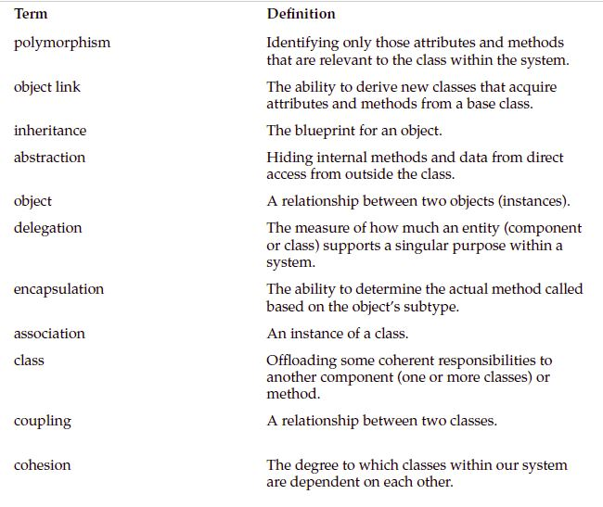

Match each workflow with its description

Answers: abstraction, inheritance, class, encapsulation, object link, cohesion, polymorphism, object,

delegation, association, coupling

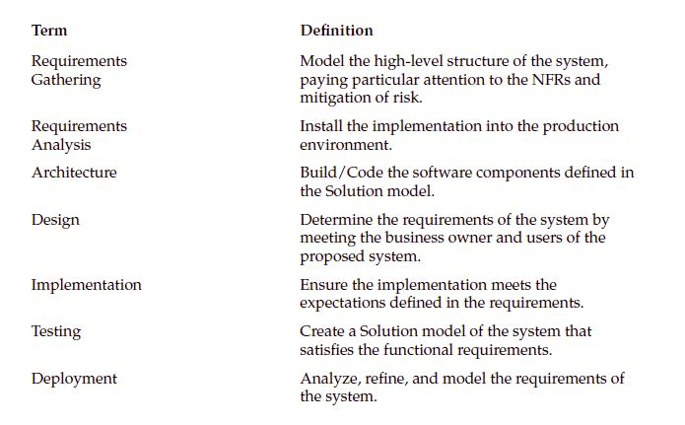

Answers: Architecture, Deployment, Implementation, Requirements Gathering, Testing, Design,

Requirements Analysis